PRESIDENT
Suzanne Greene
8738 Fairbend
Houston, TX 77055
713-467-9603 (h)
713-702-1135 (c)
gooder71@gmail.com
suzy.greene@taea.org

PRESIDENT-ELECT
Mel Basham
89 Pinemont Drive
Pointblank, TX 77364
713-299-3519 (c)
melbasham@sbcglobal.net

PAST PRESIDENT
Tim Lowke
1906 Brentwood Dr.
Leander, TX 78641
512-699-0815 (c)
tim.lowke@taea.org

VICE PRESIDENT / MEMBERSHIP
Samantha Melvin
4801 Park Rd. 4 South
Burnet, TX 78611
512-277-0510 (c)
samantha.melvin@taea.org

VICE PRESIDENT / YAM
Jen Holsinger-Raybourn
8001 Osborne Dr
Austin, TX 78729
918-809-7833
jen_raybourn@roundrockisd.org

SECRETARY
Kelley Quinn McGee
9553 Chuparosa Dr.
Fort Worth, TX 76177
817-845-3747
kmcgee@dentonisd.org

TREASURER
Jami Bevans
PMB 306, 3515 B Longmire
College Station, TX 77840
979-777-5870 (c)
jbevans@csisd.org

Ex-Officio Board Members
EXECUTIVE DIRECTOR
STAR EDITOR
Sara Chapman
1106 Wildflower Court
Katy, TX 77494
281-923-8886 (c)
281-392-1099 (w)
schapman04@comcast.net

COMMERCIAL EXHIBITS
Ricia Kerber
914 Delesandri
Kemah, TX 77565
281-957-9138
rkerber59@comcast.net

VASE DIRECTOR
Linda Fleetwood
8323 Border Knoll Dr
San Antonio, TX 78240
210-682-9362 (h)
210-381-6000 (c)
lindafleetwood@att.net

TAEA HEADQUARTERS
14070 Proton Road
Suite 100, LB 9
Dallas, TX 75244
972-233-9107 ext. 212
972-490-4219 (fax)
info@taea.org

TAEA web address -
http://www.taea.org

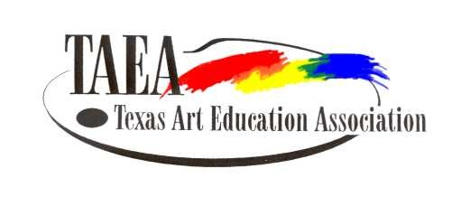
March 1, 2016

Dear Vendors,

Our commercial exhibits are one of the many highlights of our annual conference. Teachers look forward to visiting the exhibits, seeking new ways to use materials, testing new products, and taking home new ideas for students. Plans are already underway for the 2016 TAEA Conference to be held in Dallas at the Anatole, 2201 N. Stemmons Freeway.
With a total membership of 3,800 plus, TAEA works hard to put on a quality conference for its members. You are part of the reason that our members come back year after year. Our attendance last year in Galveston, was 1,948, and we are striving to increase attendance this year.

The exhibit space rates are $450.00 for one booth and $425 for each additional booth until October 1, 2016, and then the rates change to $475 per booth. TAEA requires all exhibitors to become a member of the organization. For our exhibitors, we have a sustaining annual membership; the cost is $44. Your application for exhibit space indicates the applicant’s willingness to abide by all exhibit terms, conditions and general regulations. Booths are assigned on first-served basis, and a $100 deposit is required for each booth. Final payment is due October 1, 2016. Cancellation after this date will reflect no refund of monies. Prior to this date one-half of the deposit will be refunded.
Freeman Decorating Company will provide their expertise in setting up the booths. Freeman will be handling all freight for your company, and you will hear from them after reserving your booth space, as it gets closer to the conference date.
We will continue with our custom of door prizes to be given out during our exhibition hours. Our members love all of the door prizes that are donated, and return often to the hall searching for their names in hopes of being a prize-winner. This truly does keep the flow of our TAEA members coming back for repeat visits.
We will have the smartphone app again this year. If you are a returning vendor and need to update your information, please contact me. If you are a new vendor, I will send an email and get you set up. We are looking for co-banner sponsorship for the app. The cost will be $2000 to be a banner sponsor; this will get: your logo on the app front page and 3 free alerts during the conference. For more information contact President Suzanne Greene: suzy.greene@taea.org .

Don’t be left out, reserve your space as soon as possible. I am looking forward to working for you to make this a memorable and profitable conference for you.

Ricia Kerber
TAEA Commercial Exhibits Director

Reservation for TAEA Exhibit Space
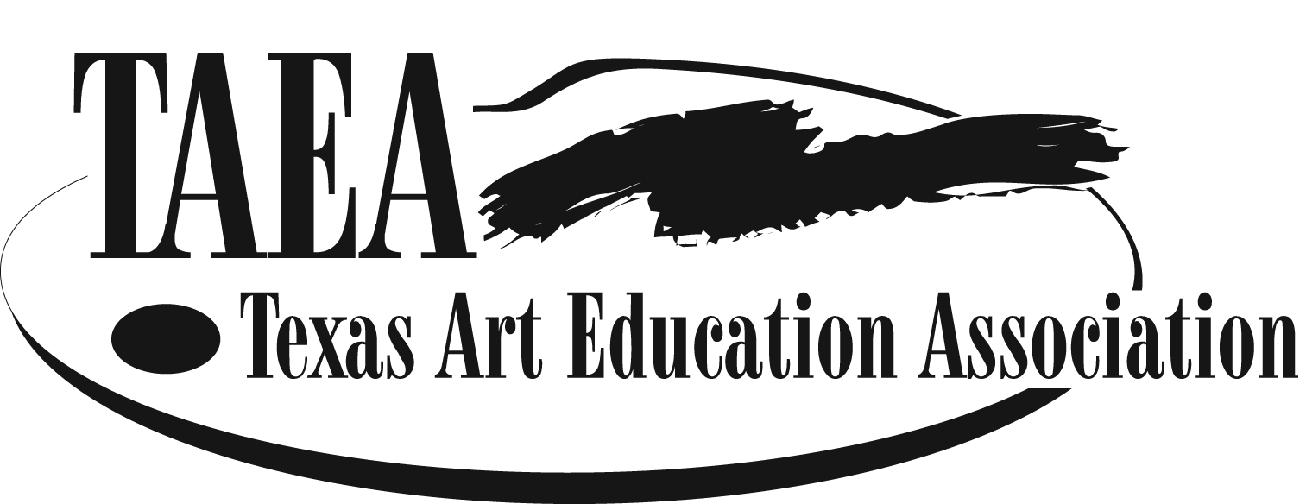
2016 Dallas Anatole
November 17-19, 2016

Exhibits are open November 17-19, 2016
Application for exhibit space at this conference indicates the applicant’s willingness to abide by all exhibit terms, conditions and general regulations

Company: |  |  |  |  |  |  |  |  |  |  |  |  |  |  |  |  |  |  |  |  | Date:
Deposit $100 per booth space

 |  |  |  |  |  |  |  |  |  |  |  |  |  | X 100 = |  |  |  | $
Number of Spaces |  |  |  |  |  |  |  |  |  |  |  |  |  |  |  |  |  | Deposit
Remaining Balance:
1st Booth $450.00 each additional booth $425.00 until October 1,2015

After October 1, 2015 the cost becomes $475.00 per booth

Sustaining Membership |  |  |  |  |  |  |  | Cost |  | $44.00 |  |  |  |  |  |  | Deposit
 |  |  |  |  |  |  |  |  |  |  |  |  | Yes |  |  | No | + Sustaining Membership
 |  |  |  |  |  |  |  |  |  | Total Paid: $
Deposit Paid By: |  |  |  |  |  |  |  | Cash |  |  |  |  |  |  |  | Check No.
 |  |  |  |  |  |  |  |  |  |  |  |  |  |  |  | Make check Payable to TAEA
Credit Card: Visa Master Card American Express
Card No. |  |  |  |  |  |  |  |  |  |  |  |  |  |  |  |  |  |  |  |  |  | Code No.
Exp. Date
Reservation Made By
Position with Company
 |  |  | You may attach Business Card
Address
City |  |  |  |  |  |  |  |  |  |  |  | State |  |  |  |  |  |  |  |  | Zip
Telephone |  |  |  |  |  |  |  |  |  |  |  |  |  |  | Fax Number
Email
Do you a have preference on location?

Reservation for TAEA Exhibit Space
Paying In Full
2016 Hilton Anatole
November 17-19, 2016

Exhibits are open November 17-19, 2016
Application for exhibit space at this conference indicates the applicant’s willingness to abide by all exhibit terms, conditions and general regulations

Company:
Date of Payment:
 |  | Number of Booths Reserved
$ |  | Amount Paid |  | Paid By:
$ |  | Sustaining Membership - $44.00
$ |  | Total Paid
1st Booth $450.00 each additional booth $425.00
1 Booth $450.00 |  |  | 2 Booths $875.00 |  | 3 Booths $1,300.00 |  | 4 Booths $1,725.00

Credit Card: Visa Master Card American Express
Card No. |  |  | Code No.
Exp. Date
Check No. |  | Make check Payable to TAEA

Reserved By
Position with Company
 |  |  | You may attach Business Card
Address
City |  |  |  |  |  | State |  | Zip
Telephone |  |  |  |  |  |  | Fax Number
Email
Do you a have preference on location?

TAEA General Regulations for Exhibitors

Sustaining Membership:
- Texas Art Education Association requires ALL commercial exhibitors to become sustaining members
- Cost is $44.00 for annual sustaining membership
- Renewal and New Vendor Applications for membership are on line at www.taea.org
Exhibitor Agrees:
- In the event of a fire, strike, or unavoidable circumstances, the Exhibitor Space Contract will not be binding
- Convention Center or TAEA will provide security and insurance for the safety of the exhibits against robbery, theft or damage by fire, accident or any other cause
- Character of the exhibits must be acceptable to the Commercial Exhibits Committee
- TAEA endorses the creativity in the use of art materials
- TAEA does not condone products and processes, which encourage imitations; or do not allow creative growth and development of children (Example: paint-by-number, coloring books, tracings etc.)
- Businesses, etc. are not permitted to remove attendees from the conference site to an outside location unless it is for off-site workshops approved by the President of TAEA
- Executive Director/President of TAEA may direct the Exhibits Committee to decline or prohibit an exhibit or portion of an exhibit, or workshop which is not suitable to or in keeping with the character of the conference or the educational philosophy of TAEA

Assignment of Booths
- First-come, first served basis
- If your choice is not available, space will assigned closest to your choice
- Floor plan is included in packet and requests for booth location will be honored to the best of our ability

Standard Booth Contract Provides:
- Booth with flame-proof back wall and drapery
- Sign carrying the exhibitor’s name
- One six foot draped table with two side chairs
- Booth size is 10’x10’ with 3’ draped sidewalls
- Security guard service provided Thursday and Friday nights
- Security will be provided when exhibits are not open
- Dimensions and locations shown on the floor plan are believed, but not warranted, to be accurate
The Commercial Exhibit Director reserves the right to make such modifications as may be necessary to meet the needs of the exhibitors. Furniture, other than that provided, such as additional tables, electrical outlets, etc. are the sole responsibility of the exhibitor and should be ordered in advance from the decorating company. Our decorator/contractor is Freeman Decorating Services, Inc. They will provide you with additional information once you have committed to exhibit. All decorative materials must be fire-resistant and in accordance with the standard established by the National Board of Fire.
Booth Information:
- Please check-in upon arrival to the Exhibits Director at the TAEA Booth located in the exhibit hall
- Exhibitors can begin setting up booths on Thursday, November 17, 2016, at 8:00 A.M.
- Pre-setup is available on Wednesday, November 16, 2015 at 1:00 P.M. at an additional cost and with prior arrangements made with the Exhibit Director
- Booth sitters may be arranged through the Exhibit Director
- Hospitality Lounge will be available for vendors, to relax and enjoy a few refreshments
- Exhibitors wishing to present a workshop must book an exhibit booth space. Proposals can be submitted on line at www.taea.org

Exhibit Hours: Times of the exhibit hall are fairly firm, but may change, as we get closer to conference time. If times are changed, notification of such will be sent via email.
- Thursday
  - 4:00 P.M. – 7:00 P.M.
  - Reception for our fabulous exhibitors will be 7:30 P.M. – 8:30P.M. after the exhibits close on Thursday. Please come as you are
- Friday
- 9:00 A.M. doors open to all of the attendees and will remain open until 2:00 P.M.
- Reopens from 4:00 until 7:00 P.M., from 4:00 till 5:00 there will be no other conference activities going on during this time
- During General Session, exhibits will be closed and exhibit area will be locked

- Saturday
- 9:00 A.M. – 2:00 P.M.
- Tear down starts at 2:15 P.M.
- TAEA will levy a fine of $200.00 for any exhibitor that breaks down early

Cancellations: If cancellation by exhibitor is necessary, your cancellation must be submitted in writing to TAEA to the exhibit coordinator at the address listed below. For cancellations postmarked before October 1, 2016, one half of your deposit will be refunded. For cancellations postmarked after October 1, 2016, no refund will be made.
Art Material Give Away: No obligation to participate
- Creates interest in the exhibit hall and keeps the crowds coming in
- Donations Do Not need to be expensive. Feel free to be creative and please be sure to attach your business card to all donated items
- Door prizes will be awarded several times an hour throughout each day of the conference
- Donors will receive recognition over the PA system in the exhibit hall
- Attendees do not have to be present to win, but must claim prize by the 2:45 P.M. on Saturday
- Prizes may be distributed to, High School, Middle School, Elementary Divisions for use as door prizes during their meeting
- Unclaimed prizes will be given to a needy school/charity chosen by the exhibits committee

It is our sincere wish that you join us and share with our members all the great things you have to offer. Texas art teachers are interested and inquisitive about your products, ideas and information. You are an integral part of a successful conference.
TAEA AD Opportunity:
 | One time | Both Pre-conference STAR and Conference Program
Eighth page (3.5”x2.5”) | $50 | $80
Quarter page (3.5” x 5”) | $75 | $130
Half page (3.5”x10” or 7”x5”) | $100 | $180
Full page (7”x10”) | $200 | $350

If you would like to advertise in the conference program, please contact our Executive Director, Sara Chapman at schapman04@comcast.net .

To place items or catalogs into conference bags or sponsor an activity, please contact our Executive Director, Sara Chapman at schapman04@comcast.net .

If you are reserving a booth or paying in full with a check please make check to: TAEA and send all information to address below.
If you are reserving a booth or paying in full with a credit card please send all information to:

Ricia Kerber
914 Delesandri Ln.
Kemah, TX 77565
Commercial Exhibit Director along with Exhibit Reservation form found on page 3 or 4

Looking forward to having you with us in Dallas, Texas

Ricia Kerber
Rkerber59@comcast.net
281-957-9138

